Art History Movie Art 21 Name:____________________
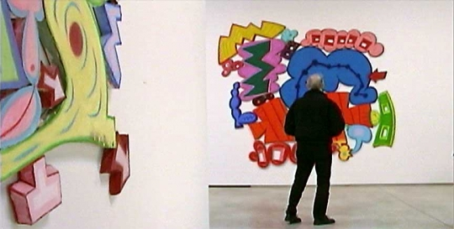
Elizabeth Murray was born in Chicago in 1940. She earned a BFA at the Art Institute of Chicago and an MFA from Mills College in Oakland, California. A pioneer in painting, Murray’s distinctively shaped canvases break with the art-historical tradition of illusionistic space in two-dimensions. Jutting out from the wall and sculptural in form, Murray’s paintings and watercolors playfully blur the line between the painting as an object and the painting as a space for depicting objects. Her still lifes are reminiscent of paintings by masters such as Cézanne, Picasso, and Matisse; however, like Murray’s entire body of work, her paintings rejuvenate old art forms. Breathing life into domestic subject matter, Murray’s paintings often include images of cups, drawers, utensils, chairs, and tables. These familiar objects are matched with cartoonish fingers and floating eyeballs—macabre images that are as nightmarish as they are goofy. Taken as a whole, Murray’s paintings are abstract compositions rendered in bold colors and multiple layers of paint, but the details of the paintings reveal a fascination with dream states and the psychological underbelly of domestic life. The recipient of many awards, Murray received the Skowhegan Medal in Painting in 1986, the Larry Aldrich Prize in Contemporary Art in 1993, and a John D. and Catherine T. MacArthur Foundation Award in 1999. Her work is featured in many collections, including Walker Art Center, Minneapolis; the Museum of Modern Art, New York; Solomon R. Guggenheim Museum, New York; the Art Institute of Chicago, and the Museum of Contemporary Art, Los Angeles. Elizabeth Murray lived and worked in New York, and died in August 2007.
- Who has inspired Elizabeth Murray?
____________________________________________________________________________________________________________________________________________________________________________________________________________________________________________________________________________________________________________________________________________________

- Describe her work. How do her paintings break tradition?
____________________________________________________________________________________________________________________________________________________________________________________________________________________________________________________________________________________________________________________________________________________
- Where has her work been shown?
____________________________________________________________________________________________________________________________________________________________________________________________________________________________________________________________________________________________________________________________________________________
- Describe something important from the video.
____________________________________________________________________________________________________________________________________________________________________________________________________________________________________________________________________________________________________________________________________________________

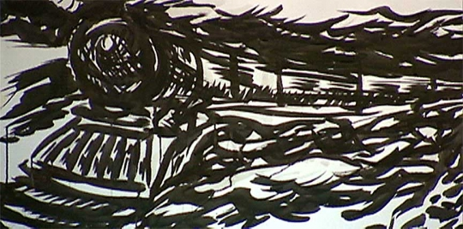
Raymond Pettibon was born in Tucson, Arizona, in 1957. The fourth of five children, Pettibon earned a degree in economics from the University of California, Los Angeles. After graduating from college, Pettibon worked briefly as a high-school math teacher, but soon set out to launch a career as a professional artist. A cult figure among underground music devotees for his early work associated with the Los Angeles punk rock scene, Pettibon has acquired an international reputation as one of the foremost contemporary American artists working with drawing, text, and artist’s books. Pettibon is as likely to explore the subject of surfing as he is typography; themes from art history and nineteenth-century literature appear in the same breath as 1960s American politics and contemporary pop culture. In his 1998 anthology, "Raymond Pettibon: A Reader," the viewer can read over Pettibon’s shoulder to discover a handful of the artist’s muses: Henry James, Mickey Spillane, Marcel Proust, William Blake, and Samuel Beckett, among others. In the 1990s, Pettibon extended his work beyond the printed page and onto the walls of the exhibition space, creating wall-size drawings and collages. Retrospectives of his work have been held at Philadelphia Museum of Art, Santa Monica Museum of Art, and the Museum of Contemporary Art, Los Angeles. In 2002, an exhibition of his drawings, "Plots Laid Thick," was organized by the Museu d’Art Contemporani de Barcelona, Spain, and traveled to Tokyo Opera City Art Gallery, and Haags Gemeentemuseum in the Netherlands. Pettibon’s work was also featured at Documenta XI in Kassel, Germany. Pettibon lives and works in Hermosa Beach, California.
- Describe Raymond Pettibon’s work. How does he break tradition?
____________________________________________________________________________________________________________________________________________________________________________________________________________________________________________________________________________________________________________________________________________________
- Where has his work been shown?
____________________________________________________________________________________________________________________________________________________________________________________________________________________________________________________________________________________________________________________________________________________
- What is the most important thing from the video?
____________________________________________________________________________________________________________________________________________________________________________________________________________________________________________________________________________________________________________________________________________________

