Art History Art 21 Movie Set Name:__________________________

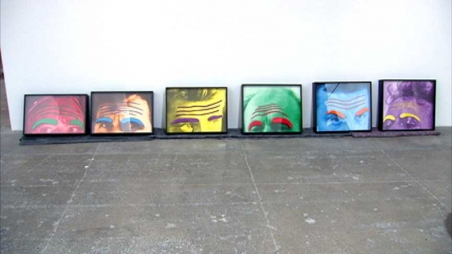
John Baldessari was born in National City, California, in 1931. He received a BA (1953) and MA (1957) from San Diego State College, continuing his studies at Otis Art Institute (1957–59) and Chouinard Art Institute. Synthesizing photomontage, painting, and language, Baldessari’s deadpan visual juxtapositions equate images with words and illuminate, confound, and challenge meaning. He upends commonly held expectations of how images function, often by drawing the viewer’s attention to minor details, absences, or the spaces between things. By placing colorful dots over faces, obscuring portions of scenes, or juxtaposing stock photographs with quixotic phrases, he injects humor and dissonance into vernacular imagery. For most of his career, John Baldessari has also been a teacher. While some of the strategies he deploys in his work—experimentation, rule-based systems, and working within and against arbitrarily imposed limits to find new solutions to problems—share similarities with pedagogical methods, they are also intrinsic to his particular world view and philosophy. Baldessari has received several honorary doctorates, the most recent from the National University of Ireland, Burren College of Art (2006). He has participated in Documenta (1982, 1978); the Venice Biennale (2003, 1997); and seven Whitney Biennial exhibitions, most recently in 2008. His work has been shown in more than 120 solo exhibitions and 300 group exhibitions. A major retrospective appeared at Tate Modern, London; the Metropolitan Museum of Art, New York; and Los Angeles County Museum of Art in 2009–10. John Baldessari was elected to the American Academy of Arts and Letters in 2007. He lives and works in Santa Monica, California.
- What is John Baldessari’s work about?
____________________________________________________________________________________________________________________________________________________________________________________________________________________________________________________________________________________________________________________________________________________
- How is his work similar to his teaching?
____________________________________________________________________________________________________________________________________________________________________________________________________________________________________________________________________________________________________________________________________________________
- Where has his work been shown?
____________________________________________________________________________________________________________________________________________________________________________________________________________________________________________________________________________________________________________________________________________________
- What is one interesting thing that he says during the video?
____________________________________________________________________________________________________________________________________________________________________________________________________________________________________________________________________________________________________________________________________________________
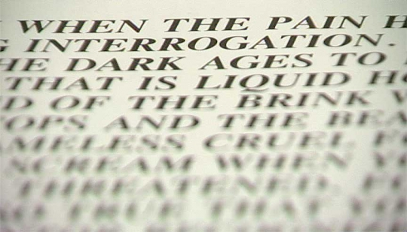
Jenny Holzer was born in Gallipolis, Ohio, in 1950. She received a BA from Ohio University in Athens (1972); an MFA from the Rhode Island School of Design, Providence (1977); and honorary doctorates from the University of Ohio (1993), the Rhode Island School of Design (2003), and New School University, New York (2005). Whether questioning consumerist impulses, describing torture, or lamenting death and disease, Jenny Holzer’s use of language provokes a response in the viewer. While her subversive work often blends in among advertisements in public space, its arresting content violates expectations. Holzer’s texts—such as the aphorisms “Abuse of power comes as no surprise” and “Protect me from what I want”—have appeared on posters and as electronic LED signs and projections of xenon light. Holzer’s recent use of text ranges from silk-screened paintings of declassified government memoranda detailing prisoner abuse to poetry and prose in a sixty-five-foot-wide wall of light in the lobby of 7 World Trade Center, New York. She has received many awards, including the Golden Lion from the Venice Biennale (1990); the Skowhegan Medal (1994); and the Diploma of Chevalier (2000) from the French government. Major exhibitions include Neue Nationalgalerie, Berlin (2001); Contemporary Arts Museum, Houston (1997); Dia Art Foundation, New York (1989); and Solomon R. Guggenheim Museum, New York (1989). Since 1996, Holzer has organized public light projections in cities worldwide. She was the first woman to represent the United States in the Venice Biennale (1990). Jenny Holzer lives and works in Hoosick Falls, New York.
- How is Jenny Holzner’s work different from what you expect art to be?
____________________________________________________________________________________________________________________________________________________________________________________________________________________________________________________________________________________________________________________________________________________
- Describe her work. What is it about?
____________________________________________________________________________________________________________________________________________________________________________________________________________________________________________________________________________________________________________________________________________________
- Where has her work been shown?
____________________________________________________________________________________________________________________________________________________________________________________________________________________________________________________________________________________________________________________________________________________
- What is something important that you learned about her from the video?
____________________________________________________________________________________________________________________________________________________________________________________________________________________________________________________________________________________________________________________________________________________

