Art History Article Questions 3 Name:______________________

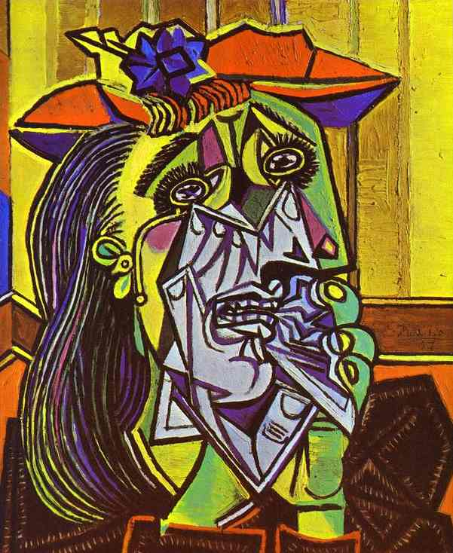

Pablo Picasso (1881-1973)
Pablo Picasso was born on October 25, 1881, in Malaga, an Andalusian city in Spain. He was the son of Don Jose Ruiz y Blasco and Maria Picasso y Lopez. Picasso is one of the greatest artists of modern art because he contributed so many works to modern painting. His career spanned more than seven decades. Picasso has been described as an infant prodigy, producing art work at an early age much like Mozart’s early experience of writing music.
In the early years, Picasso focused on painting like the great artists of history under the tutelage of his father, a traditional artist and art teacher. By the age of 13, Picasso was studying in Barcelona’s School of Fine Arts. When he transferred to Madrid’s Academy of San Fernando at age 16, he did not stay long.
Picasso moved to Paris in 1900. He shared an apartment with a writer and lived in poverty while painting furiously. Some of his early works were portraits for the Stein family, art collectors from America. By the time he painted the portrait of Daniel Stein in 1910, the Cubist style could be seen in his work.
While in Paris, Picasso became friends with a French painter, Georges Braque. Together, they established a new style of art called Cubism. In the early Cubist paintings of both artists, observers can see elements of Impressionism and Post-Impressionism even as they revolutionize compositions with geometric concepts to give volume and depth to figures and abandon traditional perspective.
In the first Cubist painting, “Les Demoiselles d’Avignon” (1907), Wilkins et al describe Picasso’s influence by Cezanne’s geometric concepts when he transformed a series of nudist paintings into the final result. “The preliminary study for the painting was in a less revolutionary style and showed two clothed male figures juxtaposed with five female prostitutes…” The final product was provocative; one woman’s female parts even face the observer head on. Three of the women also wear African masks. This painting is beautiful, angry, sexy, and puzzling all at once.
The Cubist style was copied by many artists of the early 1900s and found over several decades in Picasso’s work. For example, the great Surrealist, Salvador Dali, got to know Picasso personally and included Cubist themes in some pictures. Picasso is frequently associated with a mural painted in 1937 called Guernica (1937). He produced this work for the elected Republican government of Spain. This painting shows the bombing of Guernica during the Spanish Civil War.
A full review of Picasso’s work requires studying his many paintings created between Cubism and his death on April 8, 1973.

- How early did Picasso start painting?

______________________________________________________________________________________________________________________________________________________________________________________________________________________________________________________________________________________________________________________________________________________________________________________________________

- What style of art did Picasso help establish? Who helped him? Describe what makes that style different.

______________________________________________________________________________________________________________________________________________________________________________________________________________________________________________________________________________________________________________________________________________________________________________________________________

- Describe and critique the Picasso piece above.

______________________________________________________________________________________________________________________________________________________________________________________________________________________________________________________________________________________________________________________________________________________________________________________________________

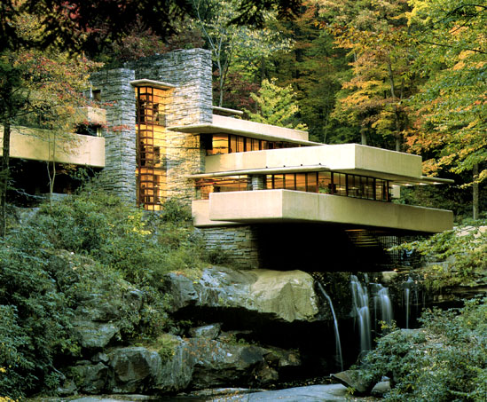

Frank Lloyd Wright (1867-1959)
You can find a glimpse of important influences in the early life of artists. This is the case for the architect Frank Lloyd Wright (1867-1959). Richard Lloyd-Jones was the Unitarian “firebrand” preacher and grandfather of the architect. Frank was the son of another preacher, William Wright, and Anna Lloyd-Jones.
In the “The Journal of American Culture” (Sept. 2009), Ingrid Steffensen notes religious influences developed young Frank’s poetic side. In the autobiography published in the Depression period, Wright described himself in the third person:
“As a listening ear, a seeing eye, and a sensitive touch had been given naturally to him, his spirit was now becoming familiar with this marvelous book-of-books, experience, the only known reading—The Book of Creation.”
A genius in design and the architect of his public image, Wright was born during Reconstruction in Richland Center, Wisconsin. He became the most influential architect of modern history. In the late 19th century, Wright left the supervision of Louis Sullivan to design homes for Midwestern clients. His trademark became the “Prairie Style” home, duplicated in many locations around the U.S. with decidedly non-prairie landscapes. Many homes are preserved in the Oak Park district of Chicago, also notable as the birthplace of Ernest Hemingway.
Oak Park also includes another Wright achievement – the Unity Temple. He designed this commission at age 38. In 1971, the U.S. Department of the Interior designated this temple as a National Historic Landmark. It is currently undergoing an extensive restoration.
A man with a distinct vision of building design, Wright believed the inside of a building was most important. “The building is no longer a block of building material dealt with, artistically, from the outside. The room within is the great fact about building-the room to be expressed in the exterior as space enclosed.” His world-famous home design, Fallingwater, challenges the idea of indoor and outdoor space. Fallingwater was built into the face of a cliff near Pittsburgh.
Wright also designed large buildings that have not survived in the 21st century, including the Larkin Office Building in Buffalo, New York, and the Imperial Hotel in Tokyo, Japan.
In celebration of its 50th anniversary, the Solomon R. Guggenheim Museum worked with the Frank Lloyd Wright Foundation to celebrate Wright’s achievements. The 2009 exhibit was called “Frank Lloyd Wright –From Within Outward.” The Guggenheim is an exquisite piece of Modernism – an ascending spiral he lovingly completed during the last decade and a half of his life. In 1959, six months after his death at age 92, the Guggenheim opened on Fifth Avenue in New York City.
Wright architecture is preserved by his self-created institution – the Frank Lloyd Wright Foundation. This organization maintains his former residence, Taliesen, in Wisconsin, and Taliesen West in Arizona. Wright also leaves the important legacy of the Frank Lloyd Wright School of Architecture, which awards bachelor’s and master’s degrees.

- What type of art is Frank Lloyd Wright best known for? What is his trademark?

______________________________________________________________________________________________________________________________________________________________________________________________________________________________________________________________________________________________________________________________________________________________________________________________________

- What were his beliefs regarding building design?
______________________________________________________________________________________________________________________________________________________________________________________________________________________________________________________________________________________________________________________________________________________________________________________________________

- Where are many of his homes preserved?

______________________________________________________________________________________________________________________________________________________________________________________________________________________________________________________________________________________________________________________________________________________________________________________________________

- What famous museum did Frank Lloyd Wright design? How did they celebrate his achievements?

______________________________________________________________________________________________________________________________________________________________________________________________________________________________________________________________________________________________________________________________________________________________________________________________________

- Describe and critique the Frank Lloyd Wright piece above.

______________________________________________________________________________________________________________________________________________________________________________________________________________________________________________________________________________________________________________________________________________________________________________________________________

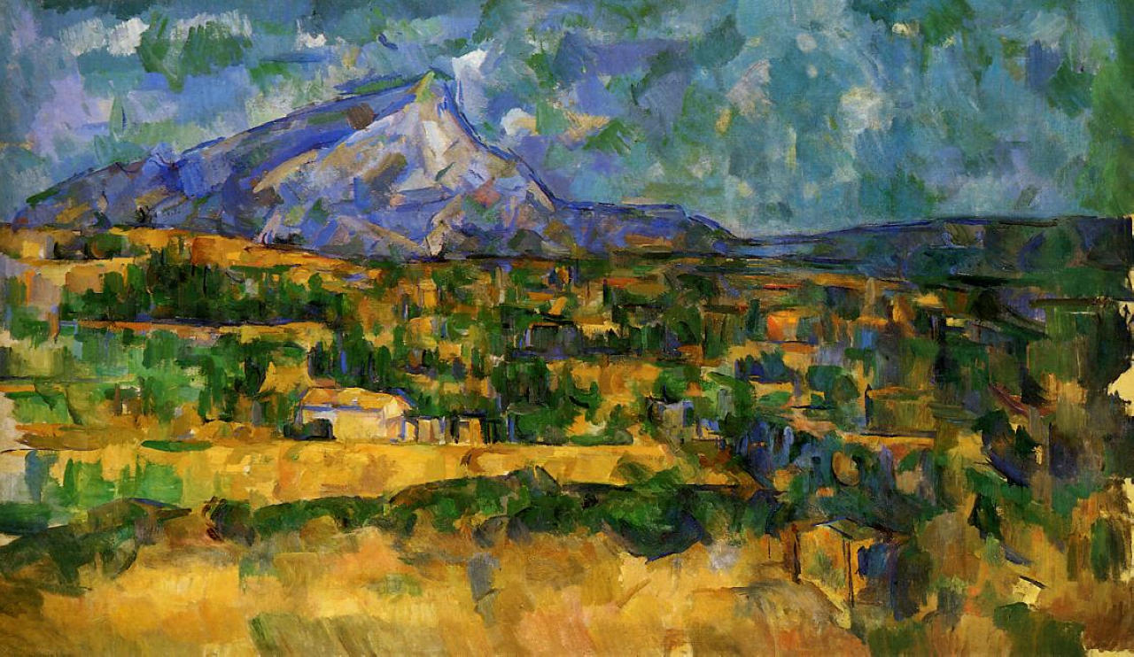

Paul Cezanne (1839-1906)
French master, Paul Cezanne is best known as a pioneer in the development of the Modernist movement of abstract painting. However, before he began challenging the conventions of art, he studied a variety of modes, eventually establishing the artistic philosophy that drove his later work. An example of Cezanne’s earliest efforts is a realistic portrait of his father. 1866’s “Portrait of the Artist’s Father” demonstrates Cezanne’s ability to capture the essence of a subject. Although his father’s image possesses a serious, uncompromising demeanor, it also reveals a faint, softness, allowing a glimpse into the conflict that all young people feel at the moment when they realize that the parents, which they have long admired and respected, are simply human beings, possessing human frailty. Painted by the artist when he was 20 years of age, this piece reflects Cezanne’s roots and foundation, from which his masterfully artistic voice would eventually emerge.
Having studied at College Bourbon, Cezanne became acquainted with artists, like Manet, Degas and Pissarro, who stoked his interest in Impressionism. The evolution of his style began with the heavy and impulsive use of oil paint, which he worked into layers, creating rich and textured images. He became focused on the ways that color could be manipulated to create perspective. One work, characteristic of his Impressionist period, is “House of the Hanged Man” from 1874. The stiff paint imitates the grainy texture of the subjects’ surfaces. The soft hues might seem accessible to the viewer. However, the tight composition of the houses creates conflict between the distant view and the unsettling lack of depth. Cezanne’s use of a steady, dispersed light challenged the Impressionists’ notion of the ephemeral effects of light.
Over the next few years, he became interested in developing a firmer structure for his paintings. Seeking to replicate nature, he reduced subjects to their most basic forms. Along with these geometric substitutions, Cezanne began using color to present an object’s basic essence. 1887’s “Mont Sainte-Victoire,” 1894’s “The House with Burst Walls” and 1905’s “Bathers” demonstrate this matured approach to his subjects. These late works illustrate his profound use of skewed, shifting perspectives, flattened, adjacent planes and subtle, transitioning tones. The tension between color and geometric forces provides energy to his paintings.
In his 1892 painting, “The Card Players,” his use of color gradations brings life to the card players, whose forms hover delicately between a flat plane and multiple perspectives. This figure composition demonstrates the artist’s continual attention to tone, color and geometry. As a highly respected French master, Cezanne’s work hangs throughout the world, in such settings as the Louvre, the Metropolitan Museum, the Hermitage Museum and the Museum of Modern Art. By developing and following his own guidelines for approaching and demonstrating abstraction, Cezanne firmly set a foundation that continues to influence arts today.

- How did Paul Cezanne challenge the conventions of art? Give three examples.

______________________________________________________________________________________________________________________________________________________________________________________________________________________________________________________________________________________________________________________________________________________________________________________________________

- Cezanne worked in multiple artistic genres. Which one did he have the most work in?

______________________________________________________________________________________________________________________________________________________________________________________________________________________________________________________________________________________________________________________________________________________________________________________________________

- How is his work from the late 1880s different from the rest of his work?

______________________________________________________________________________________________________________________________________________________________________________________________________________________________________________________________________________________________________________________________________________________________________________________________________

- Describe and critique the Paul Cezanne painting above.
______________________________________________________________________________________________________________________________________________________________________________________________________________________________________________________________________________________________________________________________________________________________________________________________________

