Art History Article Questions 2 Name: ________________________

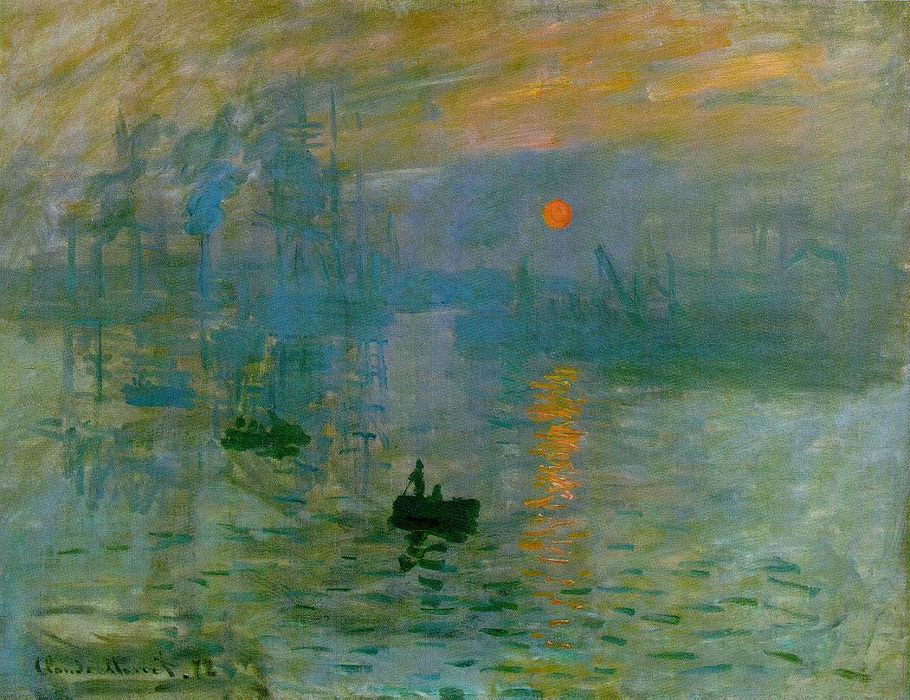
Claude Monet (1840-1926)
Did you know that the Impressionists favored the elimination of the color black from their painter’s palette? According to Wilkins et al, Impressionism encouraged this:
“The new color theory emphasized the presence of color within shadows and, in asserting that there was no black in nature, inspired the Impressionists to ban black from their palette.”
The founder of Impressionism is Claude Monet (1840-1926), a French painter born in Paris. He was a close associate of the French painter, Edouard Manet, who helped art move away from Realism in the nineteenth century. Monet served along with fellow artist Edgar Degas and author Emile Zola as a pall bearer at Manet’s funeral in 1883. Degas later created ballet scenes including 1874’s Ballet Rehearsal which showed some qualities of Impressionism.
Early in his career, Monet created a style of painting that focused on the light in the shadows. This study of natural light is the focus of his landmark painting, Impression – Sunrise, completed in 1872. This work is the source of the term “Impressionism.” Impression – Sunrise is full of powerful shades of blue, gray, and orange, and a few fishermen in small boats float in the foreground as the sun rises at the top of the painting.
Art historians note that Impressionist paintings such as Impression – Sunrise were rejected by the Paris Salon, leading the painters to hold their own autonomous shows. Monet first exhibited this work in Paris in 1874 in a non-Salon-approved exhibition. Honour and Fleming note that the independent exhibitions by the Impressionists showed how the artists were trying to escape the “tyranny of the official art-world.” In other words, if an artist could not get accepted by the Salon, he or she would have no method of becoming a professional artist in France.
Monet contributed many other paintings to the art world over the remainder of his career. He consistently explored how the human eye sees landscapes or scenes in the outdoors. He wanted to capture real events and watch how they related to the light. In Gare St.-Lazare (1877), Monet showed that a Paris train station could be the center point of the natural light shining through the glass roof on a sunny day.
The Impressionists also painted “a typically middle-class vision of happiness” in keeping with their bourgeois backgrounds, according to Honour and Fleming. The authors use the example of Monet’s sketch for The Picnic which predates Impression – Sunrise by six years. It was never finished, but it shows middle-class ladies and gentleman at a picnic beneath a beautiful canopy of trees.
As the founder of this a new style of painting, Monet left a huge mark on the art worlds of the 19th and 20th centuries. He died of lung cancer in 1926 and was buried at the church in Giverny, France.
- Describe Claude Monet’s painting above.
_________________________________________________________________________________________________________________________________________________________________________________________________________________________________________________________________________________________________________________________________________________________________________________________________________________________________________
- What art history movement did Claude Monet create and primarily work in? What made it different from other movements?
_________________________________________________________________________________________________________________________________________________________________________________________________________________________________________________________________________________________________________________________________________________________________________________________________________________________________________

- What is the Paris Salon? How did Claude Monet and other artists work around it?
_________________________________________________________________________________________________________________________________________________________________________________________________________________________________________________________________________________________________________________________________________________________________________________________________________________________________________

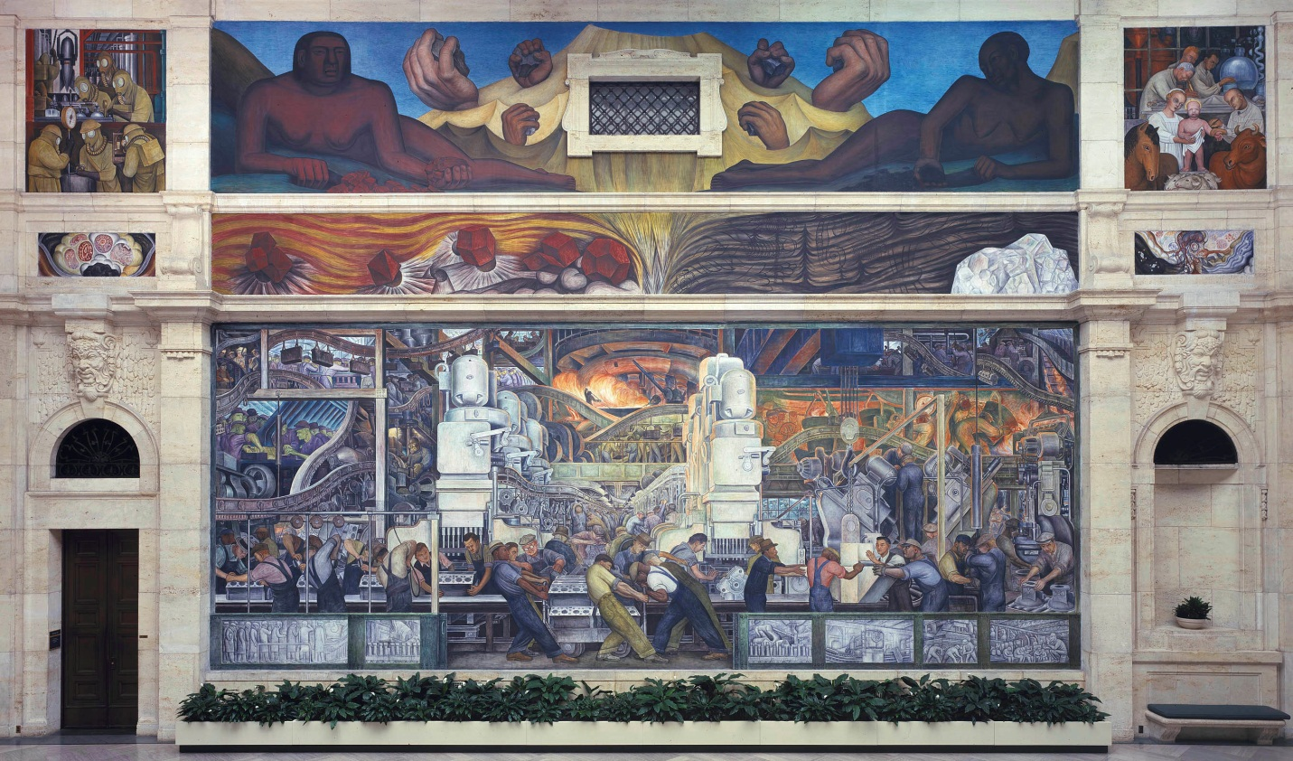
Diego Rivera (1886-1957)
Born in 1886 in Guanajuato, Mexico, Diego Rivera is one of his country’s most eminent artists along with wife Frida Kahlo (1907-1954). His murals that celebrate Mexican heritage are world famous and his life’s works have been inspirational to artists at home and abroad. Linked to revolutionary movements, Rivera’s paintings also reflect the political and industrial reality of his times.
Rivera began studying art at a young age; at ten years old he was enrolled in Mexico City’s Academy of San Carlos. His promising portfolio led the governor of Vera Cruz to sponsor his continued study in Madrid. Rivera’s tutelage in Europe also included an influential stay among the Montparnasse artists of Paris where he became friends with Pablo Picasso and Amedeo Modigliani. Art critics often point to the Picasso influence in some of Rivera’s paintings like the 1913 Woman at the Well which shows marked elements of the cubism style.
But it was the very old church frescoes of Italy that had the most dramatic influence on Rivera. Through these, Rivera became convinced that art should belong to the people—all the people, not merely the wealthy. He believed simply that the poor and working people needed art the most. His empathy for workers and the impoverished would become more pronounced with his temporarily joining the Mexican Communist Party in 1922. Eventually he would even help obtain asylum for the Russian revolutionary Leon Trotsky.
Rivera’s enchantment for revolutionaries and their ideas was often evident in his work. He frequently painted Mexican leaders who were fighting for change in their country. His exuberance for his countrymen was usually at the core of his art that, indeed, celebrates the working men and women of Mexico in colors and styles that would give the nation a truly nationalist art. Rivera also incorporated elements of Mayan art which supported his depiction of the real Mexican character.
Rivera’s prestige would earn him invitations throughout the world to paint murals and speak. One of his most famous murals abroad is Detroit Industry located in the Detroit Institute of the Arts. This mural, that includes twenty-seven frescoes, is an imposing depiction of factory workers and modern machinery. While much of Rivera’s art is in his homeland, many examples of his work can be viewed at such places at New York’s Museum of Modern Art, the Los Angeles Museum of Art, Chicago’s Art Institute, and the Buenos Aires Museo Nacional de Bellas Artes.
Rivera’s personal life was considered tumultuous. He had several marriages that produced several children and it is believed he fathered more than one illegitimate child. His most famous union was, of course, with the artist Frida Kahlo which ended at her death. Rivera died in 1957. He is best remembered for his establishment of the Mexican Mural Resistance and his subsequent murals that continue to celebrate the Mexican spirit.
- Describe Diego Rivera’s piece above.
_________________________________________________________________________________________________________________________________________________________________________________________________________________________________________________________________________________________________________________________________________________________________________________________________________________________________________

- What type of medium did he primarily work in? How was he inspired?
_________________________________________________________________________________________________________________________________________________________________________________________________________________________________________________________________________________________________________________________________________________________________________________________________________________________________________

- Where can you see his artwork? What is his most influential piece?
_________________________________________________________________________________________________________________________________________________________________________________________________________________________________________________________________________________________________________________________________________________________________________________________________________________________________________

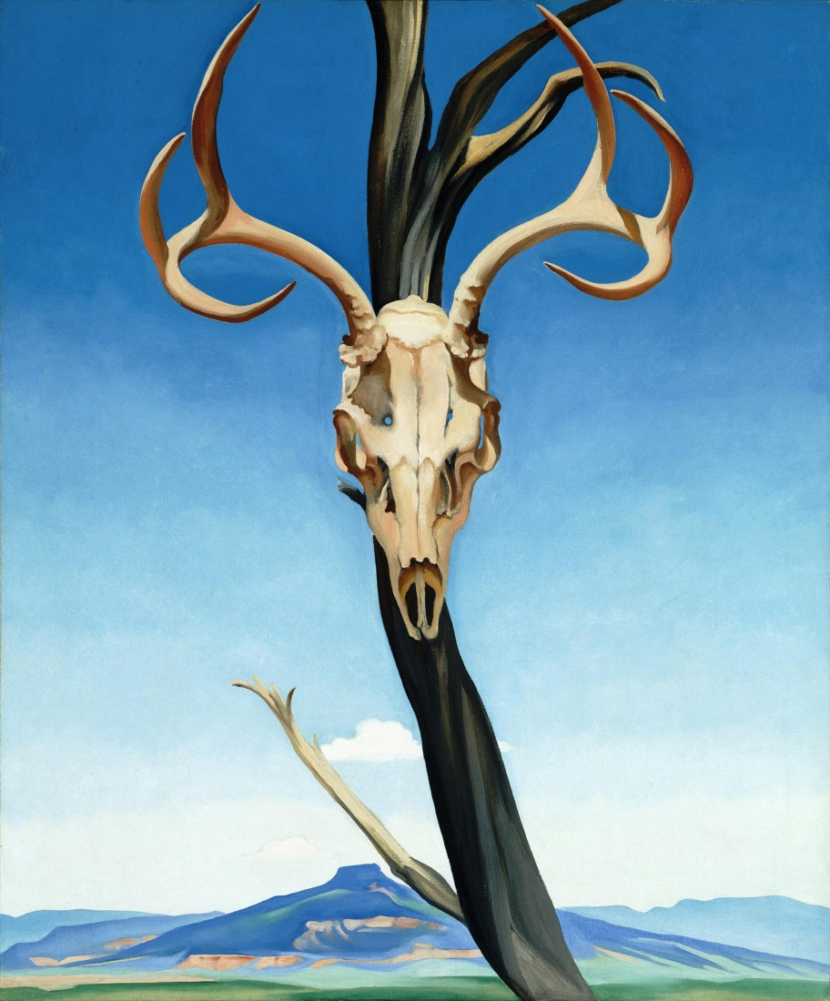
Georgia O'Keeffe (1887-1986)
Born on November 15, 1887, in Sun Prairie, Wisconsin, Georgia O’Keeffe was a female artist and icon of the twentieth century. She was an early avant-garde artist of American Modernism. Her life spanned 98 years, and her portfolio includes many works of American landscapes. She received early art instruction at the Art Institute of Chicago (1905-1907). In 1907, she moved to New York City and studied under William Merritt Chase as a member of the Art Students League. Her early career led her to further studies at Columbia University Teacher’s College and educational posts at the University of Virginia and Columbia College.
In her New York years, O’Keeffe created works described as examples of avant-garde Modernism, abstract, Minimalist, and color field theory. Two of her paintings demonstrate her lifelong skill with color regardless of the subject matter. In 1919, O’Keefe created “Blue and Green Music” and became prominent with support from Alfred Stieglitz. This abstract piece is a beautiful work of rhythm, movement, color, depth, and form. She echoes this work again in 1927 with “Abstraction Blue.” When O’Keeffe painted in watercolor or oil, she also captured beauty and emotion. In later works, O’Keeffe continued this tradition, including famous pictures of flowers and New Mexican landscapes.
O’Keeffe developed a powerful relationship with the wealthy and famous photographer, Alfred Stieglitz. The two were quite a power duo. Stieglitz is remembered as the first photographer to be exhibited in American museums, the power behind Modernist artists with his gallery 291 in New York City, the person who brought Modernism (ala Picasso) to America, and an artistic influence on artists like Ansel Adams. Although their friendship began in 1917 while Stieglitz was still married to his wife, O’Keeffe married Stieglitz in 1924.
When Stieglitz died in 1946, O’Keeffe moved from their home in Manhattan’s Shelton Hotel to New Mexico. She divided her time between a home called Ghost Ranch (frequented since the mid-thirties and purchased in 1940) and a Spanish colonial at Abiqui (purchased in 1945 and occupied in 1949). In her “Black Mesa Landscape, New Mexico / Out Back of Marie’s II” (1930), O’Keeffe again depicts movement, beauty, volume, and depth, especially in brilliant blue forms of New Mexican mountains. O’Keeffe’s work reflected other travels and influences, including a friendship with the Mexican artists, Frida Kahlo and Diego Rivera.
Georgia O’Keeffe’s cultural impact is preserved by the Georgia O’Keeffe Museum in Santa Fe, New Mexico. This museum offers the only research center in the world devoted to scholarly study in American Modernism. A visit to this museum or another venue where her work is shown suggests why she was the first woman to have a solo exhibition in 1946 at the Museum of Modern Art in New York City. O’Keeffe died on March 6, 1986.
- Describe Georgia O’Keeffe’s painting above.
_________________________________________________________________________________________________________________________________________________________________________________________________________________________________________________________________________________________________________________________________________________________________________________________________________________________________________

- What art movement was Georgia O’Keeffe a part of?
_________________________________________________________________________________________________________________________________________________________________________________________________________________________________________________________________________________________________________________________________________________________________________________________________________________________________________

- What does her work focus on? Answer as completely as possible.
_________________________________________________________________________________________________________________________________________________________________________________________________________________________________________________________________________________________________________________________________________________________________________________________________________________________________________

- Who is Alfred Stieglitz and how did he influence her?
_________________________________________________________________________________________________________________________________________________________________________________________________________________________________________________________________________________________________________________________________________________________________________________________________________________________________________

